

SIMATS SCHOOL OF ENGINEERING
SAVEETHA INSTITUTE OF MEDICAL AND TECHNICAL SCIENCES
CHENNAI-602105

ASSESSMENT 2
CSA1006-SOFTWARE ENGINEERING

Problem 1: Requirements Elicitation & Prioritization in a College Attendance System
SUBMITTED BY:
SRUTHI J – 192371085

Scenario:

A college plans to develop a College Attendance Management System. Students want a mobile app to check attendance, teachers request biometric integration, and management wants a low-cost solution delivered quickly. These conflicting requirements must be identified and prioritized.

Requirements Identification

Requirement ID | Requirement | Type
R1 | Students should be able to view their attendance percentage through a mobile application. | Functional
R2 | Teachers should record attendance using biometric authentication. | Functional
R3 | The system should generate monthly attendance reports automatically. | Functional
R4 | The system should be low-cost, secure, and completed within the project timeline. | Non-Functional

2. MoSCoW Prioritization
Requirement | Priority | Reason
Biometric attendance (R2) | Must Have | Essential to prevent proxy attendance and improve accuracy.
Attendance reports (R3) | Should Have | Helps teachers and management monitor attendance.
Student mobile app (R1) | Could Have | Improves convenience but is not critical for the first release.
Advanced customization | Won’t Have | Can be added in future releases to reduce cost and time.

3.Kano Model Classification

Feature | Category | Explanation
Accurate biometric attendance | Basic | Users expect attendance to be recorded correctly.
Automatic attendance reports | Performance | Better reporting improves user satisfaction.
Mobile attendance checking with notifications | Excitement | Provides extra convenience and improves user experience.

4. Stakeholder Conflict and Resolution

Conflict
Teachers want biometric attendance for accuracy, while management prefers a low-cost solution that can be delivered quickly.

Resolution Plan
- Conduct meetings with all stakeholders.
- Implement biometric attendance in major classrooms during Phase 1.
- Develop the student mobile application simultaneously.
- Expand biometric integration in future phases based on budget.
- Review stakeholder feedback regularly.

Block Diagram
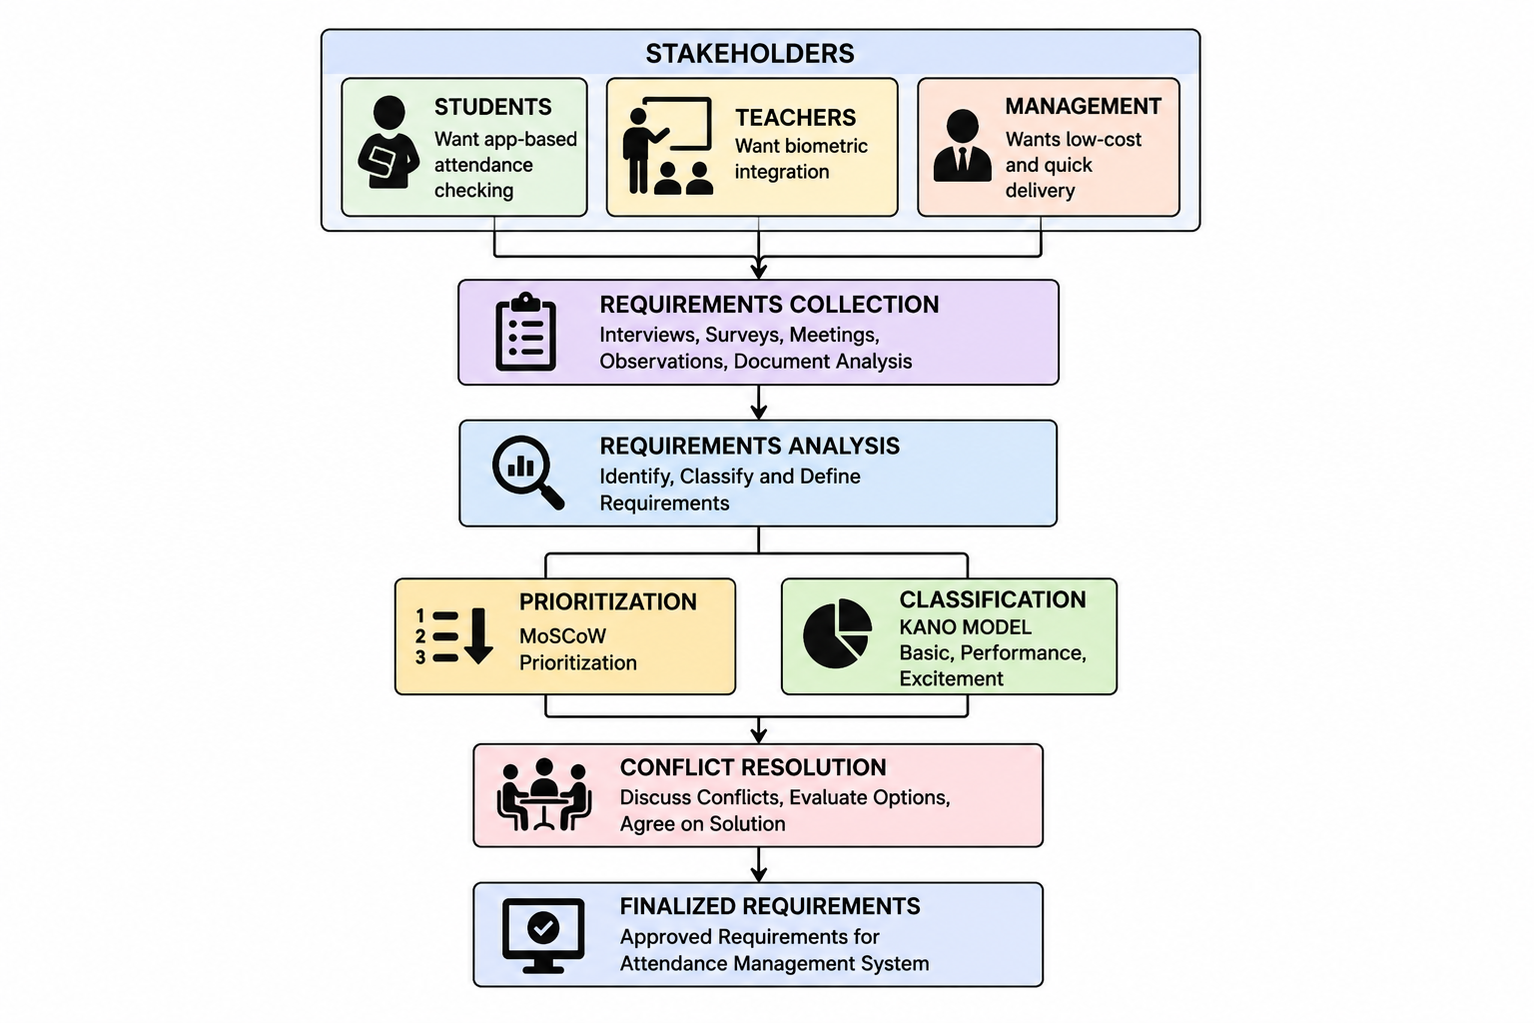

Real-World Example
Many colleges use attendance systems where students check attendance through mobile apps, teachers use biometric devices, and administrators generate automated reports. A phased implementation balances cost and functionality.

Conclusion
Requirements engineering helps identify and prioritize stakeholder needs before development. Using the MoSCoW technique and Kano Model enables teams to balance essential features, user satisfaction, budget, and project timelines.

